

APPLIED DATASCIENCE -GROUP 2

U.SWATHI

A.VIDHYA

U.SNEHA SRI

K.PAVITHRA





**CUSTOMER SEGMENTATION**

**USING DATASCIENCE**

**IDENTIFICATION OF PROBLEM IN SEGMENTING CUSTOMERS:**

1) Review industry data and market analysis:

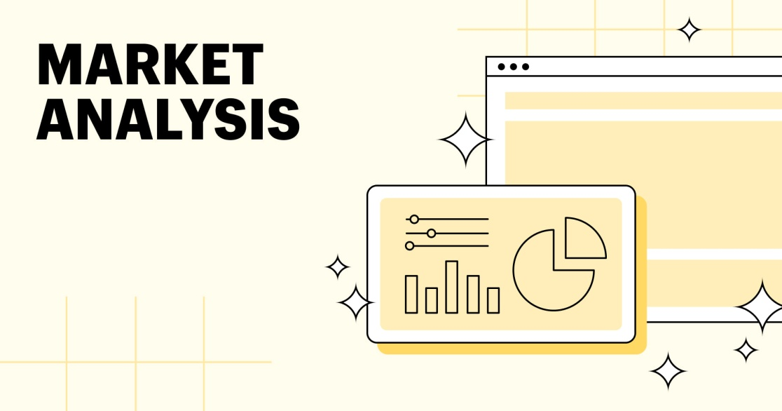

Industry analysis: Assesses the general industry environment in which you compete. Target market analysis: Identifies and quantifies the customers that you will be targeting for sales. Competitive analysis: Identifies your competitors and analyzes their strengths and weaknesses.

2) Examine your current customer base.

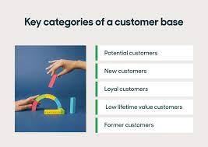

Your customer base is made up primarily of people who repeatedly buy your products or use your service

3) Choose a segmentation model:



Demographic segmentation divides customers based on factors like age, gender, and income.

4) Consider customer segmentation software:

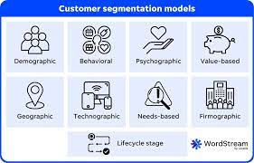

Customer segmentation software is a tool that groups your customers based on certain similarities in their demographics, behavior, or any other characteristics.

5) Collect customer experience data:

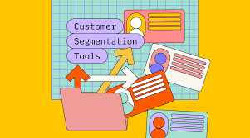

The process of collecting and analyzing customer data, with the goal of better understanding customer needs, viewpoints, and experiences with your products and services.

6) Analyze customer experience data:



Customer Experience Analysis in 3 Steps

Step 1: Choose Your Key Customer Journey Points. ...

Step 2: Gather Data on Those Customer Journey Points. ...

Step 3: Analyze Your Data to Identify Patterns and Trends.

7) Refine your customer segment:

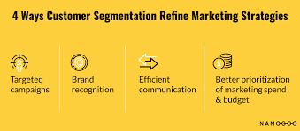

Another important way to refine your customer segments over time is to analyze data from your customer interactions and transactions. You can use tools, such as analytics, CRM, or email marketing platforms, to track and measure how your customers behave, respond, and convert across different channels and touchpoints.

**RESEARCHING THE PROBLEM IN-DEPTH IN CUSTOMER SEGMENTATION:**

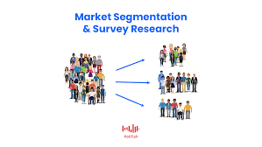

• **Data Quality and Integration**:

* **Problem**: Many companies struggle with incomplete, inaccurate, or outdated customer data. Integrating data from various sources can also be complex.
* **Impact**: Poor data quality can lead to incorrect segmentation, resulting in ineffective marketing efforts and missed opportunities.

• **Privacy and Regulatory Compliance**:

* **Problem**: Increasing concerns about data privacy and stricter regulations (e.g., GDPR, CCPA) can limit the types of data that can be collected and used for segmentation.
* **Impact**: This can hinder the depth and breadth of segmentation, making it challenging to create highly targeted segments.

• **Segmentation Overlap**:

* **Problem**: Some customers may fit into multiple segments simultaneously, making it difficult to determine which segment should be targeted.
* **Impact**: Overlap can lead to conflicting marketing strategies, potentially overwhelming customers with irrelevant messages.

• **Segmentation Drift**:

* **Problem**: Customer preferences and behaviors can change over time, causing segments to become less accurate or outdated.
* **Impact**: Outdated segments can result in misaligned marketing efforts and lost opportunities.

• **Resource Intensiveness**:

* **Problem**: Developing and maintaining a segmentation strategy can be resource-intensive in terms of time, expertise, and technology.
* **Impact**: Smaller businesses with limited resources may struggle to implement effective segmentation strategies.

**IDEATING POSSIBLE SOLUTION:**



• **Data Quality and Integration**:

* **Solution**: Invest in data cleaning and validation processes to ensure data accuracy. Implement a data integration strategy to consolidate customer data from various sources into a single, comprehensive view.

• **Privacy and Regulatory Compliance**:

* **Solution**: Stay compliant with data privacy regulations and obtain clear consent for data usage. Collect only necessary data and anonymize or pseudonymize sensitive information when possible.

• **Segmentation Overlap**:

* **Solution**: Develop a hierarchy or prioritization system for segments to handle overlapping customers. Create clear rules for assigning customers to segments based on their primary characteristics.

• **Segmentation Drift**:

* **Solution**: Regularly update and reevaluate customer segments to account for changing behaviors and preferences. Implement automated tracking systems to monitor segment performance.

• **Resource Intensiveness**:

* **Solution**: Prioritize segmentation efforts based on potential impact. Consider outsourcing data analysis or segmentation tasks to experts if resources are limited.

**CREATING A PROTOTYPE:**

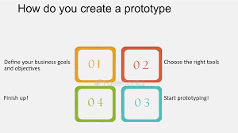

Creating a prototype for customer segmentation involves developing a simplified version of your segmentation strategy or model to test its feasibility and effectiveness before implementing it on a larger scale.

**TESTING AND TROUBLESHOOTING:**

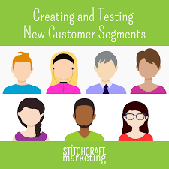

Creating and troubleshooting customer segmentation is an iterative process. Regularly review and adapt your segmentation strategy to meet evolving customer needs and market dynamics. Keep stakeholders informed and engaged throughout the process to ensure alignment and support for your segmentation efforts.

**Troubleshooting Common Issues**:

1. **Inaccurate Segmentation**
2. **Segment Overlap**:
3. **Segment Drift**:.
4. **Data Quality Problems**:
5. **Lack of Actionability**:
6. **Resistance to Change**:
7. **Low ROI**:
8. **Ethical Concerns**:
9. **Ineffective Personalization**:

**MAKING IMPROVEMENTS TO AND RELEASING THE FINAL PRODUCT:**

Creating and improving a customer segmentation strategy is an ongoing process that involves continuous refinement and adaptation. To release a final product or version of your customer segmentation strategy, follow these steps:

**1. Review Existing Segmentation**

**2. Define Objectives**

**3. Collect Comprehensive Data**

**4. Data Quality Assurance**

**5. Update Segmentation Variables**

**6. Choose Segmentation Methods**

**7. Segment the Data**

**8. Profile the Segments**

**9. Develop Marketing Strategies**

**10. Implementation Plan**

THANK YOU

SUBMITTED BY

A.VIDHYA